Middle River Terrace Neighborhood Association
2016 Membership Form
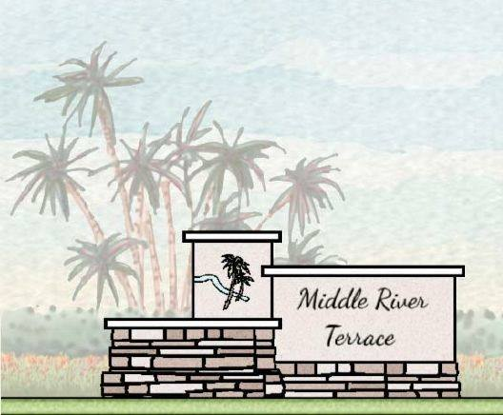
Please Help Support the MRTNA with your annual $25 Membership
It's the time of year when we ask for your support by joining or renewing your Middle River Terrace Neighborhood Association Membership which helps to promote improvements within our community. We are designated a "Neighborhood" (not just a Homeowner) Association, which encourages everyone to be involved and to help make Middle River Terrace a better place to live. When you become a member, you will be a partner in the community, with full access to our webpage and email messages with important time sensitive information. Meet your neighbors, provide input, and vote on important issues. A full year's membership is just $25 which includes (2) members per household.
For a mere 48 cents per week, your membership helps keep the good work going!

Benefits of membership include:

*Vote on important issues *Have input on neighborhood improvements
*Voice your concerns * Get to know your neighbors
*Become a member of the Board *Full access to MRTNA webpage
*Make a Difference!

Middle River Terrace Neighborhood Association is a non-profit organization. No board or elected official receives any financial remuneration. All board and elected officials are volunteers working for the improvement of our neighborhood.
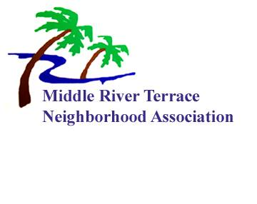
Memberships run January 1st – December 31st
You can sign up easily on our website @ www.middleriverterrace.org
Method of payments accepted are PayPal or a credit card!

2016 Annual Membership - $25.00 per household (includes 2 memberships)
Add $10.00 for each additional household member
Business Memberships $100.00 – (includes 1 membership)

You can also mail your membership application and check to:
Middle River Terrace Neighborhood Association
PO Box 4561
Fort Lauderdale, FL 33338
2016 MEMBERSHIP MAIL IN FORM
Name: ____________________________________________________________________
Additional Member: _________________________________________________________
Address: __________________________________________________________________
Fort Lauderdale, FL Zip: ____________________________________________________
Email: ____________________________________________________________________
Additional Member(s) if applicable: ____________________________________________
Please enclose your check made payable to MRTNA
MIDDLE RIVER TERRACE NEIGHBORHOOD ASSOCIATION
$25.00 per household (includes 2 memberships)
$10.00 for each additional member in the household
Business Memberships - $100.00

THANK YOU FOR YOUR CONTINUED SUPPORT!

